Hosting a Static Website on Azure Storage with CDN Integration

Created by- Siddhant Bisht

Created on- 03 August 2025

Here are the steps I performed-

1. Create an azure storage account.

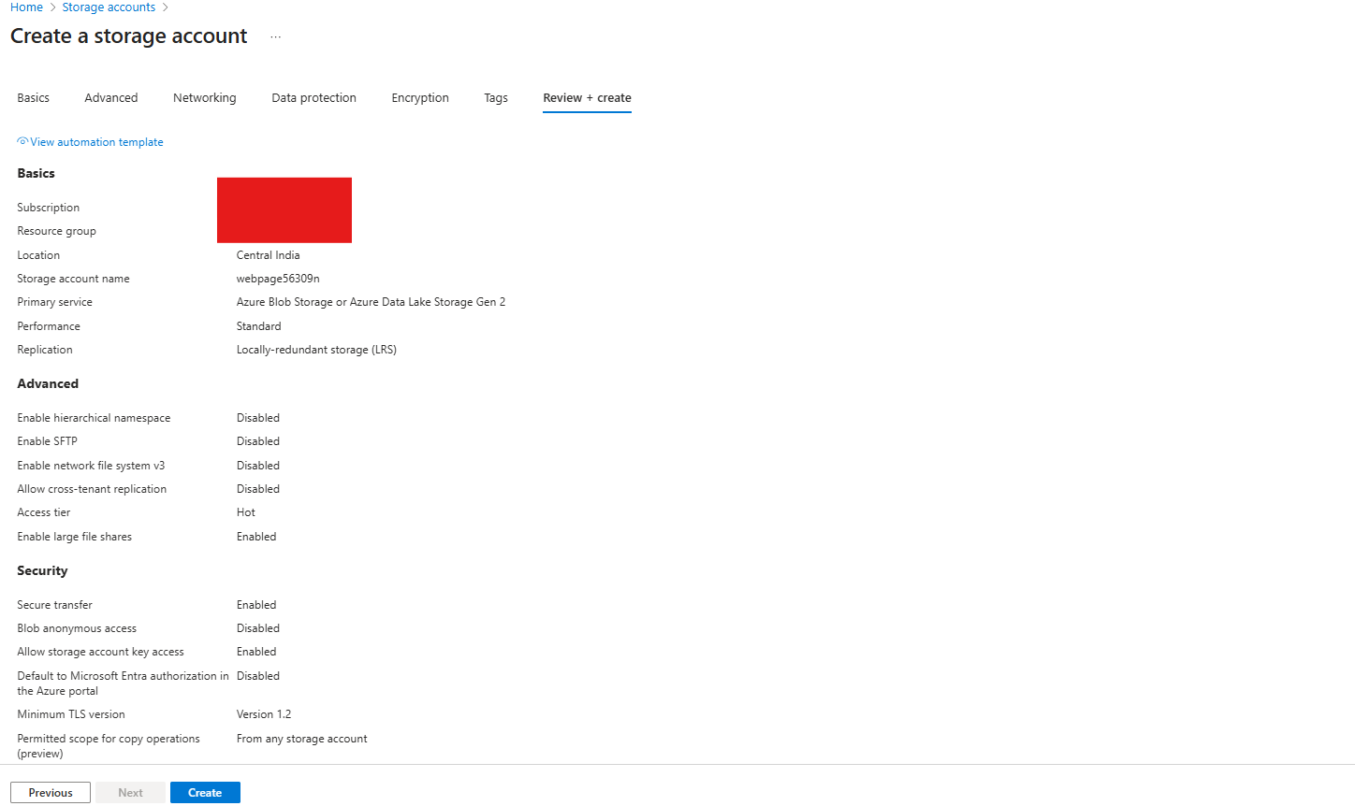

1. Locate the static website hosting on the left pane of Storage account and enable it.

1. Prepare your code and make sure they are in the same location (I added style.css to a subfolder but they need to be in the same folder, as we can only upload files in container not folder but we can create one, then I changed the code and added style to the same location as other files, the picture here shows before changes were made so make sure you don’t make the same mistake).

Here I also created an error file so that instead of having a generic or technical-looking error (like “404 Not Found”), users see a branded, friendly page that helps them stay on the site. With a custom error page, we keep users on your site longer, we can add internal links to guide them back (home, blog, contact) and also this reduces bounce rate and improves the search ranking.

1. As we have enabled the static website hosting inside the blob container, we can see the $web container created. It’s where we have to upload our code.

1. Once upload is completed, move to the static website on the left pane, you will see a primary endpoint, copy the url and search it on your browser.

1. With the url you will be able to see the web page you created.

1. Now we can add an endpoint to access the web page, for that move to Front Door & CDN in the storage account. Why we need CDN here well, CDN copies the website’s static files (HTML, CSS, JS, images) to edge servers located around the world. When a user visits the website, the content is served from the nearest CDN location, not from the location of storage account. This reduces latency, meaning faster load times for global users. Create an endpoint & copy the url of the endpoint.

1. Now if you will try to access the website from the url of the endpoint you will be able to see the code.

1. We can also add custom domain which points to our website. Here we can also upload and use a custom SSL certificate or use Azure-managed HTTPS. This makes the website look more professional and SEO-friendly. To add custom domain, move to the endpoint and find custom domain where you can add your domain. Make sure you have added a Cname record entry for the endpoint url in your DNS provider as well.

1. Your website now accessible from your custom domain as well.

Check reference link for static website - <https://learn.microsoft.com/en-us/azure/storage/blobs/storage-blob-static-website>

GitHub - <https://github.com/Siddhantbisht9>